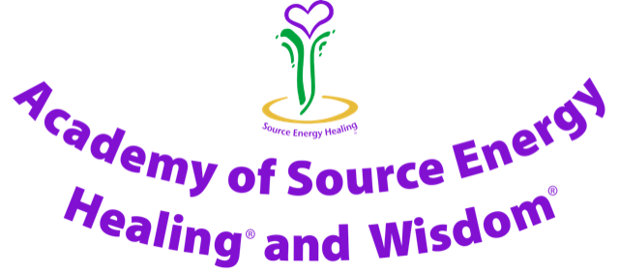

Module Two – Practitioner Training

The Mission Statement of the Academy

To deliver professional
Source Energy Practitioner Training
to empower Practitioners to deliver
Hands-on and Distant Healing
as well as Guidance Card sessions.
To help clients physically, mentally,
emotionally and spiritually
with empathy and integrity.

Codes of Practice of the Academy for Module Two

The Academy of Source Energy Healing® and Wisdom® Codes of Practice set out the standards of conduct, ethics and competence required of Practitioners and Ambassadors to promote their clients’ health and general wellbeing, protect them from harm and maintain public confidence in the Academy and Source Energy.
These standards provide the framework to support the delivery of ethical, competent and safe Source Energy care. These Codes of Practice also form an important part in the requirements for professional training with the Academy.
These Codes of Practice set out the requirements of a Source Energy professional Practitioner. Clients need to be able to trust their Practitioners with their health and well-being. To justify this trust, Source Energy Practitioners must meet the standards expected by the Academy of Source Energy Healing® and Wisdom®.

The Codes of Practice are arranged in the following main categories:

Membership of the Academy and use of the Logo
Communication and client partnership
Knowledge, skills and performance
Safety and quality in practice
Professionalism

Membership of the Academy and use of the Logo
Source Energy Healing®, Source Energy Wisdom® and the Source Energy Healing® Logo are all covered by International Trade Marks.
To use Source Energy Healing® and the Source Energy Healing® Logo you need Jillian’s permission, and also need to be a current member of the Academy of Source Energy Healing® and Wisdom®.
Attending this Source Energy Healing® Module Two Professional Practitioner training course provides you with membership of the Academy of Source Energy Healing® and Wisdom® to the end of August following your qualification as a Source Energy Healing® Practitioner.
A year’s current professional membership is £38 with membership running from the first of September to the end of August the following year. You need to renew your membership annually so that you can continue to use Source Energy Healing® and the Source Energy Healing® Logo. Copies of your current professional insurance document and ICO membership need to be produced at the time of payment of your annual membership fee.
If your contact details change between the time that you first qualify and the end of August, please let your Jillian have your new contact details.
As a member of Source Energy Healing® you are permitted to use the Source Energy logo on a dedicated Source Energy website, or on a separate page within your own website and you are undertaking to maintain all aspects of these Codes of Practice.

The printed Modules and booklets of the Academy remain the property of the Academy. If, at any time in the future, you decide that Source Energy is not for you, or your decide not to renew your membership, you undertake to return all printed Modules and Booklets to the Academy by special delivery within one month.
Please do not share your own Unique Source Energy Code with anybody, as this would dissipate the energy and prevent you from connecting.
Source Energy can only be taught by one of the qualified Source Energy Teachers (Ambassadors). To maintain the clarity and confidentiality of Source Energy we trust you not share any of the paperwork or information with anyone and to keep your Modules in a secure place and do not attempt to teach Source Energy.
To use Source Energy professionally you need to be covered by insurance. Balens in Malvern are happy to arrange this for you. You need to comply with the Continuing Professional Development criteria.
To ensure that the integrity of Source Energy is maintained do not mix the sessions with any other healing modality or therapy.
Communication and Patient Partnership
Listen carefully to clients and respect their individuality, concerns and preferences. Practitioners need be polite and considerate with clients and treat them with dignity and courtesy.
Receive valid consent and ensure that the Consent Form is completed, signed and dated by all clients. Minors must have the written consent of their parent/guardian, who needs to be present during the session, or their chosen representative needs to be present.
Maintain and keep safe comprehensive, accurate, legible, complete and up to date clients’ records. Comply with the General Data Protection Regulations and register with the ICO.com as appropriate.
Respect the clients’ dignity and modesty and explain to them what they can reasonably expect from a Source Energy session.
Knowledge, Skills and Performance
All Source Energy Practitioners need to have the knowledge and skills to support their Source Energy professional practice, develop these throughout their Source Energy journey and to work within the limits of their knowledge, skills and experience.
Source Energy Practitioners need to keep their professional knowledge and skills up to date, through attendance at training/refresher days when called upon to do so.
Safety and Quality in Practice
All Source Energy Healing® Practitioners and Teachers need to deliver high quality and safe Source Energy sessions to their clients and ensure that their Source Energy practice space is safe, clean and hygienic and complies with health and safety regulations.
Professionalism
All Source Energy Healing® Practitioners and Teachers need to act with honesty and integrity and uphold high standards of professional and personal conduct, including personal hygiene, to ensure public trust and confidence in the Academy and Source Energy.
Please uphold the reputation of the Academy and Source Energy at all times through your conduct, in and out of the workplace, and lead a Source Energy Living life.
Support colleagues and co-operate with them to enhance client care. Be honest and trustworthy in all professional and personal financial dealings. Maintain the pricing structure agreed for the country in which the Source Energy sessions are given. Do not share any of the information with others, thank you.

