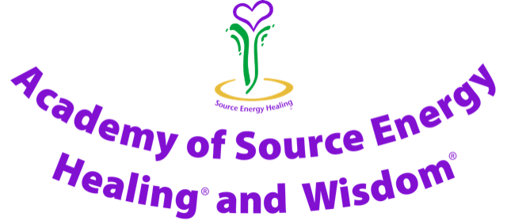

The Mission Statement of the
Academy for Module One – Personal Soul Growth

To deliver professional
Source Energy Healing® Training
to empower Module One Participants
to treat themselves with
Source Energy Healing.
To help Module One Participants
physically, mentally,
emotionally and spiritually,
with empathy and integrity
and to progress on their own unique soul journey.

Codes of Practice of the Academy for Module One

These Academy of Source Energy Healing® and Wisdom® Codes of Practice set out the standards of conduct, ethics and competence required of Module One Participants to maintain public confidence in the Academy and Source Energy. These standards provide the framework to support the delivery of ethical, competent and safe personal Source Energy care.

These Codes of Practice set out the requirements of a Module One Source Energy Healer, for their own personal Soul Growth. All Source Energy Healers, whether they are using the Healing for their own personal Soul Growth or as a professional Practitioner need to meet the standards expected by the Academy of Source Energy Healing© and Wisdom©.

The Module One Codes of Practice cover the following:

Membership of the Academy and use of the Logo

Source Energy Healing®, Source Energy Wisdom® and the Source Energy Healing® Logo are all covered by International Trade Marks.
(To use the Source Energy Healing® name and the Source Energy Healing® Logo you need Jillian’s permission, and also need to be a current professional member of the Academy of Source Energy Healing® and Wisdom®. This is available after completing Module Two.)
Attending a Source Energy Healing® Module One course provides you with Associate Membership of the Academy of Source Energy Healing® and Wisdom® to the end of August following the successful completion of Module One.
A year’s current associate membership for Module One participants, who are able to use Source Energy Healing for their own Personal Soul Growth, is £18 with membership running to the end of August. You need to renew your membership annually so that you can continue to use Source Energy Healing® for your own Personal Soul Growth. If your contact details change between the time that you first qualify and the end of August, please let Jillian have your new contact details.
The printed Modules and booklets of the Academy remain the property of the Academy. If, at any time in the future, you decide that Source Energy is not for you, or you decide not to renew your membership, you undertake to return all printed Modules and Booklets to the Academy by special delivery within one month.
Do not share your own Unique Source Energy Code with anybody.
Source Energy can only be taught by Jillian and the Source Energy Teachers (Ambassadors). So that we can maintain the clarity and confidentiality of Source Energy we ask you not to share any of the paperwork or information with anyone and to keep your Module in a secure place. Please do not attempt to teach Source Energy.
As a Module One participant you are able to use Source Energy Healing® for your own personal soul growth. You may also use it for a few close family members. In order to use Source Energy Healing professionally you will need to complete Module Two, when you can charge a fee once you have obtained professional insurance.

These Codes of Practice are in place to ensure that we all maintain the integrity, purity, confidentiality and uniqueness of Source Energy and the wonderful benefits that it brings.

